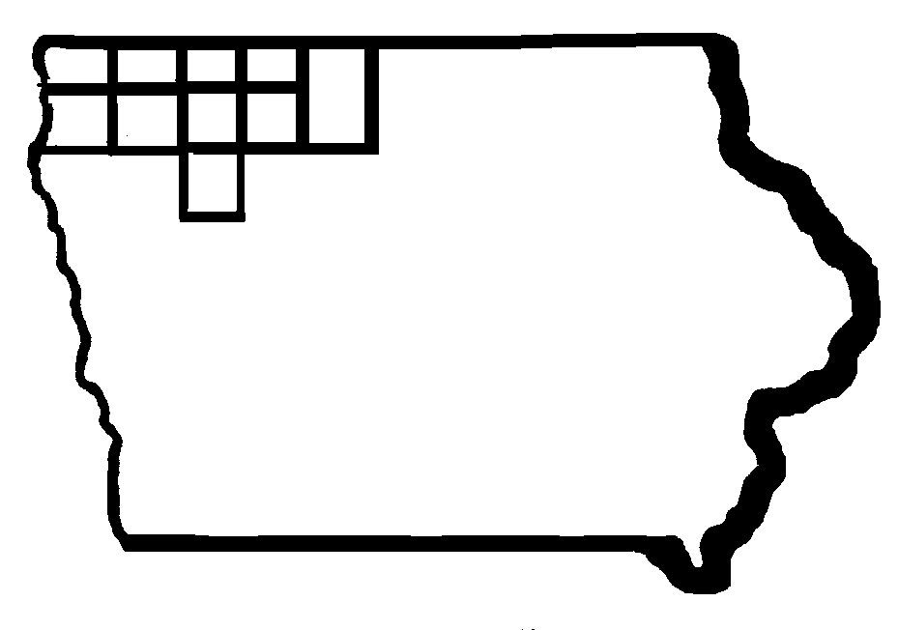Iowa Region 3 & 4

CEO - RWDB

RWDB Chair: Dale Arends
CEO Chair: Barry Anderson

Region 3 & 4 Chief Elected Official Board and
Regional Workforce Development Board Combined Meeting
Thursday, May 28, 2020
9:30 a.m. to 11:30 a.m.
Governmental Services Center, 217 West 5th Street, Spencer
Due to the COVID-19 outbreak this will not be a face to face meeting!
Join via Google Hangouts Meet or Phone
Meeting ID
meet.google.com/qpo-sojz-sks

Phone Numbers
(‪US‬)‪+1 301-857-1194‬
PIN: ‪635 063 894#‬

- Call to Order

- Roll Call of Members, State Staff and Guests

- Welcome

- Agenda Review

- Approval of March 26, 2020 RWDB-CEO Meeting Minutes and Ratification and Approval of April 4, 2020 RWDB-CEO Executive Committee Meeting Minutes
  - RWDB Vote
  - CEO Vote

- WIOA Core Partner Update – Adult Education and Literacy, Iowa Dept. for the Blind, Iowa Vocational Rehabilitation (WINTAC Process)

- IWD Appointment for Employment Services Position on RWDB
  - CEO Vote

- Title II (Adult Education and Literacy) Alignment Review Report – AEL Review Committee

- RWDB Reappointments 2020
  - Beem
  - VerSteeg
  - Jager-Pippy
  - Arends (Reva)
  - Rettey
  - Nelson (Vern)
    - CEO Vote

- Update on becoming a WIOA Compliant Region (CEOs)
  - RWDB Board Update – required members aligned by gender and political affiliation
    - Appointment of Region 3-4 WIOA Compliant Board for Region 3-4 – CEO Vote
  - RWDB Member Conflict of Interest Statement Update
  - Update on Appointment of Title I Adult/DW and Youth Service Provider through 12/31/2020 Goodwill Industries of the Great Plains
  - PY20 July 1, 2020 to June 30, 2021 Draft Budget
  - Region 3-4 Budget for Required Positions of the Board (Admin. Money for Region) –
    - RWDB Vote
    - CEO Vote
      - Board Support
      - Fiscal Agent
      - One-Stop Operator
  - Region 3-4 Contracts for positions of the Board
    - Board Support
    - Fiscal Agent
    - One-Stop Operator
    - Service Provider
  - Training for New Positions of the Board
    - Board Support
    - Fiscal Agent
    - Service Provider
    - One-Stop Operator
  - Title I Adult/DW and Youth Service Provision RFPs beyond 12/31/2020
  - Region 3-4 One-Stop Operator Procurement by 12/1/2020
  - Close Out Plan for Current Service Provider
  - Future Steps: Local Plan Rewritten, Memorandum of Understanding (MOU) to include cost-sharing agreement

- One-Stop Program Updates
  - Region 3-4 One-Stop Statistics
  - WIOA Title I Expenditure Report through 04/30/20
c. PY19 WIOA Title I Performance
d PROMISE JOBS Update
e. Wagner-Peyser Update

- Regional Disability Standing Committee – Lori Kolbeck

- State Staff Update

- Partner Update

- Confirm Next Meeting Date and Adjournment (September 26, 2020)

Accommodations are available upon request for individuals with disabilities. To request an accommodation, please contact: access@iwd.iowa.gov

