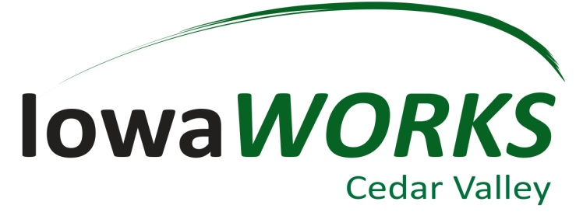

3420 University Avenue

Waterloo, IA 50701

Conference Line:

1-866-685-1580

Conference Code

4772635870

Region 7

Youth Standing Committee

Monday, May 18, 2020

4:00 – 5:00 pm

AGENDA

1. Welcome & Introductions
2. Approval of agenda
3. Approval of minutes – 04/27/20
4. WIOA Title I Youth Standing Committee updates- Michele
5. Update on WIOA Title I Youth Programming – Michele
6. Agency Updates – ALL
7. Next meeting – Monday, July 27, 2020 at 4:00pm.
8. Adjourn