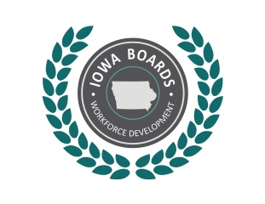 | Notice of Public Meeting:  Disability Access Committee of the  Region 3-4 Workforce Development Board
Date: | November 10, 2020
Time: | 9:00 am
Place: | Virtual Meeting via zoom
Phone: | 1 312 626 6799 Meeting ID: 987 4000 5573 Passcode: 535710
Internet: | https://zoom.us/j/98740005573?pwd=eDRibWV4R1MrZHljUThMaDdwQ3RTQT09

Tentative Agenda:
- Call to Order.
- Establish quorum.
- Approval of Agenda.
- Approval of 8/4/2020 minutes
- Discussion Items:
  - NDEAM Activities
  - Physical and Program Accessibility
  - Training Needs
  - Outreach and Intake, Business Services
- Action Item:
- Next Meeting- schedule

Accommodations:
Accommodations are available upon request for individuals with disabilities. If you need an accommodation, please contact:
Name: Lori Kobeck, IVRS Supervisor and Committee Chair
Email: lori.kolbeck@iowa.gov
Phone: 515-573-8175

More Information:
For more information, please visit: www.IowaWDB.gov

