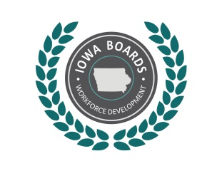 | Notice of Public Meeting:  Disability Access Committee of the  North Central Iowa Workforce Development Board
Date: | 11/23/2020
Time: | 9:00 am
Place: | Via Zoom
Phone: | 312-626-6799 Meeting ID: 94507383321 Passcode: 922900
Internet: | https://zoom.us/j/94507383321?pwd=enFmS1crMGF4MXoyQnN1MmxJVGtoUT09

Tentative Agenda:
- Call to Order.
- Establish quorum.
- Approval of Agenda.
- Approval of Meeting Minutes from 8/24/2020
- Discussion/Open Issues
  - Board vote on committee
  - Physical and Program Accessibility- any updates
  - Training- future needs/plans
  - NDEAM and follow up
  - Other updates
- Schedule Next Meeting:
- Adjournment

Accommodations:
Accommodations are available upon request for individuals with disabilities. If you need an accommodation, please contact:
Lori Kolbeck
Email: lori.kolbeck@iowa.gov
Phone: 515-573-8175

More Information:
For more information, please visit: www.IowaWDB.gov

