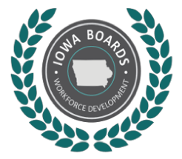
Southwest Iowa Local Workforce Development Board Finance Committee
Friday, October 28, 2022 at 12 pm- Zoom
- Call to Order: Carol Smith-Chair
- Agenda Approval
- September Minutes Approval
- Monthly Financial Report
- Invoice Approvals
- Establish Next Meeting: September 21 at 12 pm
- Public Comment
- Adjournment
Jesse Bolinger is inviting you to a scheduled Zoom meeting.

Topic: SWIAWDB Finance Committee
Time: Oct 28, 2022 12:00 PM Central Time (US and Canada)

Join Zoom Meeting
https://us02web.zoom.us/j/88501946654?pwd=UGZtVFZJNUR0Z2gvSG8vbExRd3BQQT09

Meeting ID: 885 0194 6654
Passcode: 618351
One tap mobile
+13092053325,,88501946654#,,,,*618351# US
+13126266799,,88501946654#,,,,*618351# US (Chicago)

Dial by your location
+1 309 205 3325 US
+1 312 626 6799 US (Chicago)
+1 646 931 3860 US
+1 929 436 2866 US (New York)
+1 301 715 8592 US (Washington DC)
+1 360 209 5623 US
+1 386 347 5053 US
+1 564 217 2000 US
+1 669 444 9171 US
+1 669 900 6833 US (San Jose)
+1 719 359 4580 US
+1 253 215 8782 US (Tacoma)
+1 346 248 7799 US (Houston)
Meeting ID: 885 0194 6654
Passcode: 618351
Find your local number: https://us02web.zoom.us/u/kdrUj7zlH7

