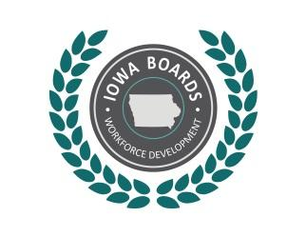 | Region 12 Workforce Development Board  Disability Access Committee

Member Information Matrix
Name | Organization | Program/Affiliation | Email
Adam Dahlke | Iowa Vocational Rehabilitation | Vocational Rehabilitation | Adam.Dahlke@iowa.gov
Carlos Montas | Iowa Department for the Blind | Vocational Rehabilitation | Carlos.Montas@blind.state.ia.us
MacKenzie Reiling | Iowa Workforce Development | Workforce Services | Mackenzie.Reiling@iwd.iowa.gov
Trisha Sadler | Goodwill | Iowa Workforce Development | Trisha.Sadler@iwd.iowa.gov
Mindy Collins | Iowa Vocational Rehabilitation | Vocational Rehabilitation | Mindy.Collins@iowa.gov
 |  | Community-Based Organization
Craig Levine | IBEW | Union-affiliated Registered Apprenticeship Program | Ibew231cl@cableone.net
Pam Wooldridge | Western Iowa Tech Community College | Adult Education & Literacy service provider | Pamela.woolridge@witcc.edu
Marcia Rosacker | Wells Enterprises, Inc | Business | mlrosacker@bluebunny.com

Updated on December 15, 2017

