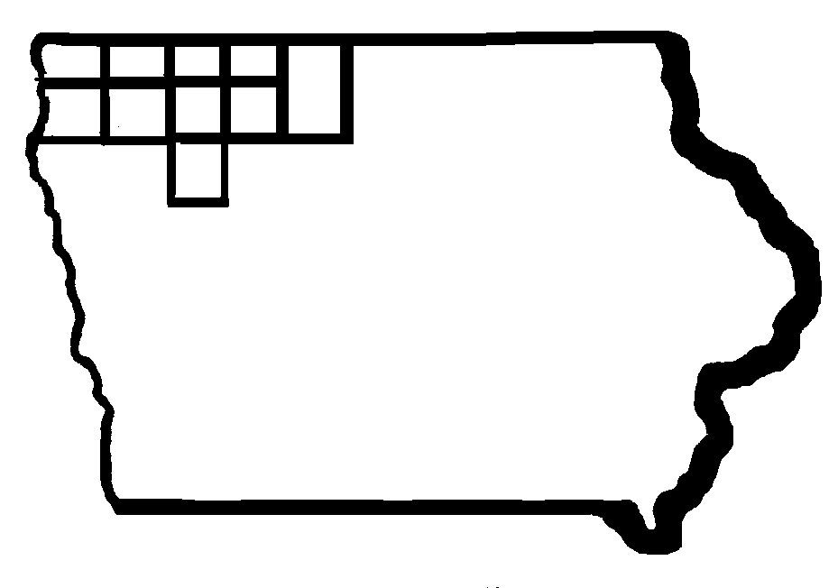

Iowa Region 3 & 4

CEO - RWDB

RWDB Chair: Janet Dykstra
CEO Chair: Dale Arends

Region 3 & 4 Chief Elected Official Board Meeting and
Regional Workforce Development Board Meeting

Wednesday, October 18, 2017
1:30 p.m.
Teleconference

Please Dial: 877-820-7831
Passcode: 317597

Members of the public may join this conference call at IowaWORKS – 217 West 5th Street, Spencer, Iowa

- Call to Order

- Roll Call of Members

- Agenda Review

- Vote to approve the Region 3-4 One-Stop Certification 2017
A. RWDB Vote
B. CEO Vote

- Confirm Next Meeting Date and Adjournment

Next Meeting Date: January 25, 2018
Location: IowaWORKS - Spencer

If you have any questions, please feel free to contact Val Bonney, at
712-262-1971 Ext. 42010 or at val.bonney@iwd.iowa.gov

