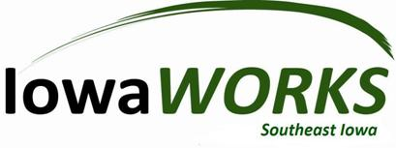

Agenda

Region 16 Chief Elected Official/Regional Workforce Development Board
Wednesday, April 4, 2018, 10:00 AM – 11:00 AM
Burlington IowaWORKS

Regional Realignment Discussion CEOs

* Items requiring a vote

Mission: To champion the Workforce Center’s role in building a highly skilled market-ready workforce that strengthens the economic vitality of the Great River Region.
Vision: The Great River Region Workforce boards envision the Workforce Center as being proactive, adept and flexible in providing timely solutions to meet the ever-changing demands of the workforce of the Great River Region.

