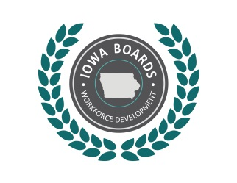 | Region 7 Workforce Development Board  Disability Access Committee

Member Information Matrix
Name | Organization | Program/Affiliation | Email
Mike Howell, Chair | Iowa Vocational Rehabilitation Services | Vocational Rehabilitation | Michael.Howell@iowa.gov
Joe Weigel, Vice Chair | Iowa Department for the Blind | Vocational Rehabilitation | Joe.Weigel@blind.state.ia.us
Marissa Thornton | Hawkeye Community College | Adult Education & Literacy | Marissa.Thornton@hawkeyecollege.edu
Suzy Schlette | Iowa Workforce Development | Workforce Services | Susan.Schlette@iwd.iowa.gov
Rachel Faust | RainSoft of NE Iowa | Union-Affiliated Registered Apprenticeship Program | rsrachelf@rainsoftneiowa.com
Kim Kalkhoff | Inclusion Connection | Community-Based Organization
Brenna Schaefer | Iowa Workforce Development | Disability Employment Initiative | Brenna.Schaefer@iwd.iowa.gov
Kylie Murphy | Iowa Workforce Development | Disability Employment Initiative | Kylie.Murphy@iwd.iowa.gov
Deborah Collett | Bloom Manufacturing, Inc. | Business | dcollett@bloommfg.com

Updated on June 20, 2018

