IOWAWORKS – IOWA VALLEY – REGION 6
CHIEF ELECTED OFFICIALS AND REGIONAL WORKFORCE DEVELOPMENT BOARD MEETING
Wednesday, January 16, 2019 at 5:00 P.M.
IowaWorks Building, 2nd Floor
3405 S Center Street, Marshalltown, Iowa 50158
MINUTES
CEO Members- Attended: Jason Roudabush, Steve Salasek (Vice Chair), Lance Granzow and Kendall Jordan was absent.

RWDB Members- Jason Roudabush, Marty Hardon (Chair), Nancy Roethler (Vice Chair), Bob Jeske, Jim Hunt, Eric Evans, Lori Wildman, Jackie Gray, and Lynn Olberding
Members absent: Jon Nunez, Arturo Sanchez, Jason Schomer, Brian Sokol and Rachel Bly

Others Present- Neysa Hartzler, Beth Severidt, Rebecca Hassett, Janet Stegmann, Kathleen Geiken and Angela De La Riva

A quorum was met for both CEO and the RWDB meeting.

- Call to Order-Marty Hardon
  - Additions/Deletions to the Agenda-none
  - Approval of the Agenda

CEO Action:
Motion by Granzow, second by Salasek, to approve the agenda as printed.

Roll Call Vote: Ayes___X___ Nays______
RWDB Action:
Motion by Roethler, second by Jeske, to approve the agenda as printed.

Roll Call Vote: Ayes___X___ Nays______

- Correspondence and/or Visitors-Marty Hardon
2.1-Introductions-All members present made introductions including new member Jason Roudabush, as well as Janet Stegmann, Kathleen Geiken and Angela De La Riva

3.0 Election of Officer(s)-Appoint new CEO Chair to fulfill the unexpired term of CEO Chair Diana Dawley and possible election of a new CEO Vice Chair.

CEO Action:

Motion by Granzow, second by Salasek, to appoint Jason Roudabush as CEO Chair to fulfill the unexpired term of CEO Chair Diana Dawley.

Roll Call Vote: Ayes__X____ Nays______

CEO Action:

Motion by________, second by__________, to appoint _________as CEO Vice Chair.

Roll Call Vote: Ayes______ Nays______

- Economic Development Updates-Marty Hardon
  - Tama County Update –Marty Hardon
Tama Pack adding 2nd Shift, Rendering Company is adding jobs

  - Poweshiek County Update –Jason Roudabush
Update on Wind Turbine projects

  - Marshall County Update –Lynn Olberding
Disaster Loan Fund-17 local businesses, RACOM application offering incentives, IN dialog with Lennox Co. in adding 200 new jobs in manufacturing

  - Hardin County Update- Angela De La Riva
Ackley-1 new business, 2 business expansions in the works, CDBG Grant-Iowa Falls-Homebased Iowa

- Partner Updates-Marty Hardon
Neysa Hartzler-Commented on Arturo’s greatest concern which involves getting a new location for Iowa Workforce Development staff as they will need to be out of the current building by April 1st, as the building has been sold. Arturo’s report attached.
Eric Evans-Commented they are still short staffed and scraping by.
6.0 Action Items-Marty Hardon
6.1 Approval of Minutes (October 17, 2018)
CEO Action:
Motion by Salasek, second by Granzow, to approve the October 17, 2018 minutes as written.

Roll Call Vote: Ayes___X___ Nays______
RWDB Action:
Motion by Hunt, second by Olberding, to approve the October 17, 2018 minutes as written.

Roll Call Vote: Ayes___X___ Nays______
6.2 A request to seek grant opportunities for funding Limelight Leadership Academy- Becky Hassett
CEO Action:
Motion by Granzow, second by Roudabush, to approve seeking grant opportunities for Limelight Leadership Academy.

Roll Call Vote: Ayes___X___ Nays______
RWDB Action:
Motion by Jeske, second by Gray, to approve seeking grant opportunities for Limelight Leadership Academy.

Roll Call Vote: Ayes___X___ Nays______

7.0 Discussion/ Information Items: Becky Hassett
- Youth Standing Committee Update- Eric Evans, Becky Hassett, working on building this committee, to meet quarterly like RWDB meetings
- Orientation to Partner Services Workshop- Discussion Item Becky Hassett-getting a lot of referrals for Core Partners, sign-up and start intake process at workshop
- Job Fair- Discussion item from Beth Severidt-Feb. 20th 10-12:30pm.
- Introduction of New Career Development Advisor- Janet Stegmann
- Amendment (Attached)- Adding 9 month funds, Recapture/Redistribution funds- Becky Hassett-Received funding in January and the rest of the funding will come at second quarter
- AIWP Board Training (Attached)- Becky Hassett-CANCELLED
- WINTAC Integration Assessment- Becky Hassett, Arturo Sanchez, Eric Evans, Jon Nunez- This is a statewide assessment to see how we are doing statewide in the integration process
- Relocation Update- Becky Hassett-Still in search for a facility. Need to be out of current building by April 1st. Encouraged members to seek possibilities.
- Title I Annual Report (Attached)- Becky Hassett
8.0 Upcoming Events/Programs Updates
Job Fair Coming Up-Feb 20th, 2019

9.0 Schedules for Future Meetings
Future RWDB/CEO meetings will be held quarterly – January, April, July and October. The meetings will be held at 5:00 p.m. on the 3rd Wednesday of these months. Next meeting will be April 17, 2019. Location for April meeting is unknown at this point.

10.0 Adjournment
The meeting was adjourned at 5:40 p.m.

Submitted by Lisa R. Gassman
Board Secretary

CANCELLED
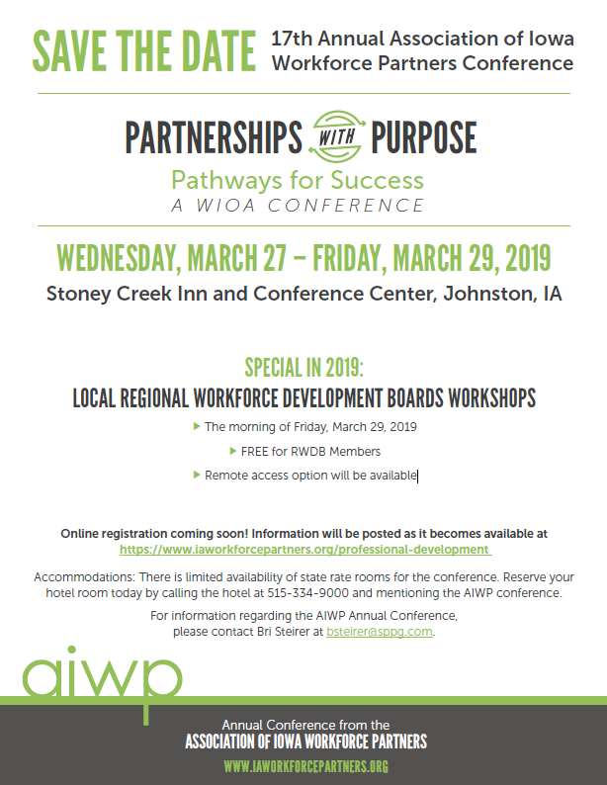

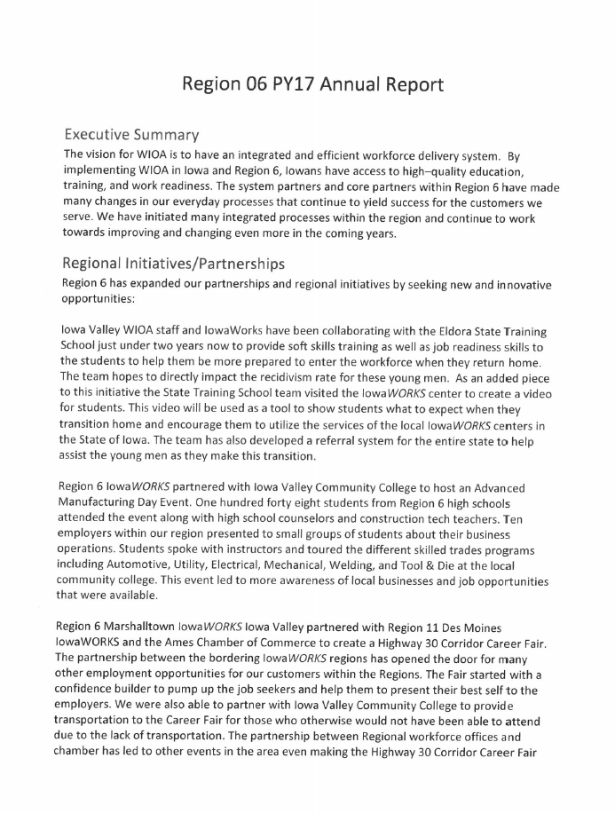

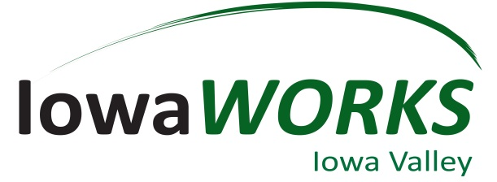
RWB Report – January 16th, 2019
Fiscal Year Updates:
1433 new members from October 1st 2018- December 31st 2018- New Members that have visited or have utilized our services in the last 3 months.
- October 350
- November 553
- October 530

96 New work registrations- Members that never had an Iowa Jobs account.
126In-person contacts, with 73 of them being New Business contacts
336 Job seekers attended 72 scheduled workshops. (809 were scheduled for a 41% attendance rate)

Office Top Priorities:
- Need a temporary location as a short-term solution until “new” building is ready for us. IowaWORKS has to be out of the current building by April 1st.
- Need a new office- We need all the help we can get from the Board Members to find a building in Marshalltown.

Business Services Updates:
- 12 different employers hosted in the center for open interviews.
- 51 open interviews scheduled in the office.
- 229 documented services provided to businesses.
- State of Iowa Initiatives.
  - Future Ready Iowa (70% of Iowa’s workforce to have education or training beyond high school by 2025). See attached Map and Dates for Future Ready Iowa Summits across the State.
  - Minority Unemployment subcommittee
  - Register Apprenticeships
  - Home Base Iowa
- Rapid Response Events/ Business Closings.
  - 10/01/2018 Iowa Works staff and service partners did 1 Rapid Response meetings for the Women’s Center (formerly Marshalltown OB GYN). About 8 staff were affected.
  - 11/30/18 UnityPoint layoffs
  - 12/28/2018 Payless closed
- Past Events:
- Oct 15- Presentation to 120 MHS students (IWD services, FRI, RA and Maria's success story- Motivational)
- Oct 18 and 19- Did NCRC testing at AGWSR High School in Ackley for 11 students
- Oct 19- IJAG Observation at Miller Middle School and meeting with Director Laurie
- Oct 22 and 23- Did NCRC testing at Grinnell High School for 135 students
- Oct 23- Assisted with mock interviews at Iowa Falls/Alden High School
- Oct 25- Partnered with IVRS to hold a “Disability Awareness Event” at the Iowa Valley Education & Training Center
- Oct 29- Presentation to South Tama High School (35 Students) (IWD services, FRI, RA and Maria's success story- Motivational)
- Oct 30- Participated with Iowa Valley staff for the “Financial Literacy Fair” held at MCC. High schools who attended were West Marshall, East Marshall, South Tama, and MHS
- Nov 1- Arturo, Neysa, and Maria attended the graduation for new Workforce Advisor Mary Anna Lyons who will be working at the Newton Correctional Facility site. Learned about the prison and got a complete tour of the facility.
- Nov 9- Combined event for both Veteran’s Day and National Apprenticeship Week. Partnered with the Iowa Army National Guard in Marshalltown to hold a “Veterans Appreciation Day & Open House/Recruiting Event” and employers came to the ECI event in the morning targeting veterans in Registered Apprenticeships. The agenda included basic understanding of registered apprenticeships, the training involved, and guest speaker Lori Wildman from Alliant Energy gave a presentation on their success with having registered apprenticeships.
- Dec 11- GMG Presentation (IWD services, FRI, RA and Maria's success story- Motivational)
- Dec 13- Neysa gave brief presentation on services and was part of the panel discussion for the Iowa Valley Leadership class held in Dejardin Hall.
- Dec 17- GMG Presentation (IWD services, FRI, RA and Maria's success story- Motivational)
- Upcoming Events:
  - 02-20-2019- Hwy 30 Corridor Career Fair and Reverse Job Fair at MCC/Iowa Valley.
  - 03-07-2019- ECI event on SIDES (State Information Data Exchange System), simplifying unemployment insurance information requests which will be held at our Iowa Works center.

