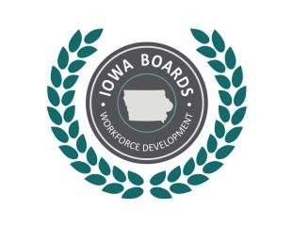 | Notice of Public Meeting:  Disability Access Committee of the  Region 12 Workforce Development Board
Date: | 5/23/2019
Time: | 3 pm- 4 pm
Place: | WITCC, Wells Fargo Room-ADS L110, 4647 Stone Ave, Sioux City, IA 51106
Phone: | 712-233-9030
Internet: | www.iowaworkforcedevelopment.gov

Tentative Agenda:
- Call to Order.
- Introductions/Role Call-Establish quorum.
- Action Item: Approval of Agenda.
- Action Item: Approval of Previous Meeting Minutes (March 29, 2019).
- Discussion/Open Issues:
A. Look at the one-stop certification, what parts refer to serving those with disabilities, what we can do differently or try to do?
B. Part of the mission, it says the group should review customer satisfaction with programmatic and physical accessibility. We should decide how we are going to collect this information, what to ask, and so on.
C. Look at how well we all serve people with disabilities? (Survey- VR, Geosolutions)
- Committee Report: Comments, if any, from Disability Access Committee members.
- Public Report: Comments, if any, from attendees of the meeting.
- Schedule Next Meeting.
- Adjournment.

Accommodations:
Accommodations are available upon request for individuals with disabilities. If you need accommodation, please contact: Mindy Collins, EMAIL: mindy.collins@iowa.gov Phone: 712-255-9971
More Information:
For more information, please visit: www.IowaWDB.gov

